Headers in Rest API:

Headers are additional pieces of information that are sent along with the request to the server. They provide metadata about the request or response, such as the content type of the request body, the authentication token, or the software client making the request. Headers are separate from the request body and are usually used to provide metadata about the request.

Some commonly used headers in REST API calls include:

* **Accept**: Specifies the content type that the client expects to receive in response to the request.
* **Content-Type**: Specifies the media type of the request body.
* **Authorization**: Specifies the authentication token or credentials for the request.
* **User-Agent**: Specifies the software client making the request.
* **Cache-Control**: Specifies caching behavior for the request and response.
* **If-None-Match**: Specifies a conditional request based on the ETag header value.

Headers can be included in REST API calls using the HTTP **header** field. Headers are usually represented as key-value pairs, and are separated from the request body by a blank line.

**Why are Headers Important in REST API Calls?**

Headers are essential for REST API calls, as they provide additional information that is not included in the request body. They can be used to control the behavior of the server in handling the request, to provide authentication information, or to provide additional metadata about the request or response. Headers can also be used to provide information about the response, such as the content type and length of the response body.

**How to Use Headers in REST API Calls?**

Let's say we're building an e-commerce platform, and we want to create a REST API endpoint for processing orders. The API should allow clients to submit orders, and the server should respond with the status of the order. Here's an example of what the request might look like, along with the headers that could be included:

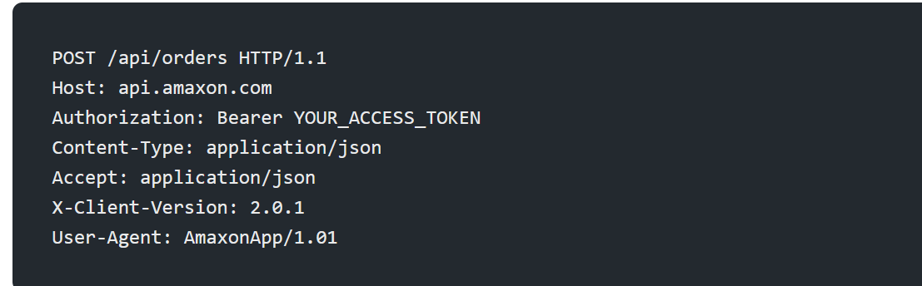

In this example, the request method is POST, and we're sending the request to the /api/orders endpoint on the api.amaxon**.**com server. The **Authorization** header is used to authenticate the request with an access token, and the **Content-Type** header specifies that the body of the request is in JSON format. The **Accept** header specifies that we want the response to also be in JSON format.

The **X-Client-Version** header provides information about the version of the client making the request. This can be useful for server-side analytics, allowing us to track which client versions are most popular or which versions are experiencing the most errors. The **User-Agent** header is used to identify the client making the request, which can be helpful for debugging or troubleshooting.

The request body might look something like this:

